Simulate a small network with switches and multiple devices. Use ping to generate traffic and observe the MAC address table of the switch. Capture packets using Wireshark to analyze Ethernet frames and MAC addressing.
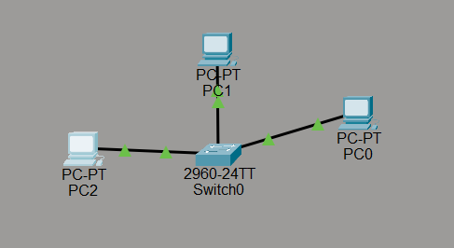
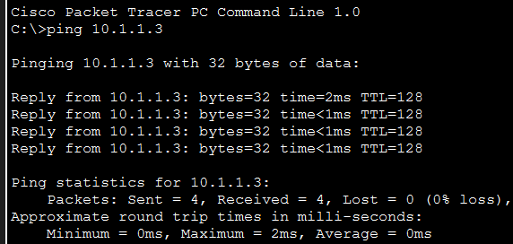
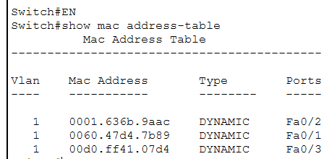
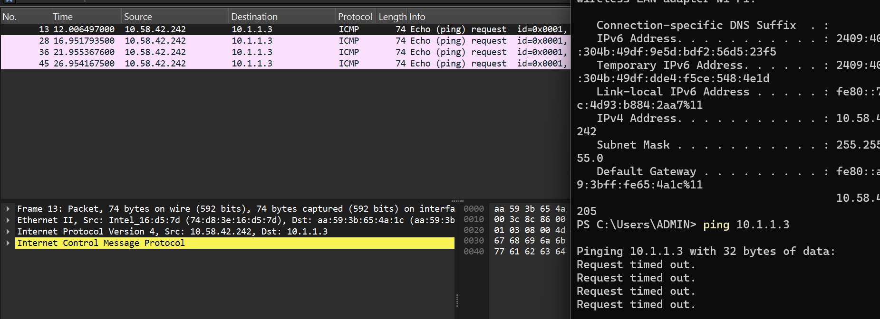
Capture and analyze Ethernet frames using Wireshark. Inspect the structure of the frame, including destination and source MAC addresses, Ethertype, payload, and FCS. Use GNS3 or Packet Tracer to simulate network traffic.
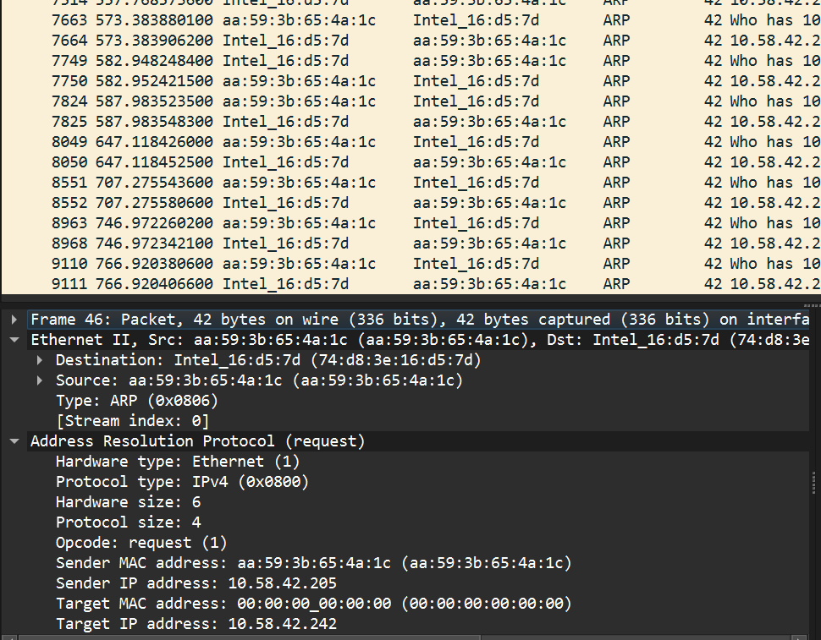
Troubleshoot Ethernet Communication with ping and traceroute -> Using cisco packet tracer:
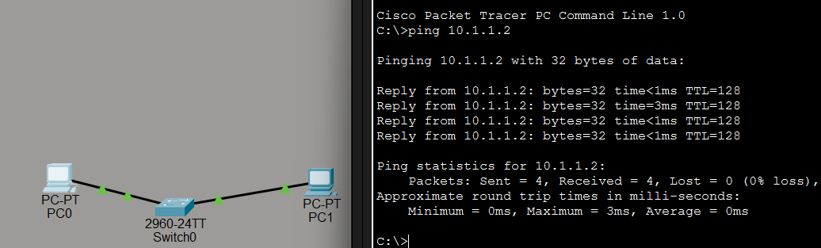
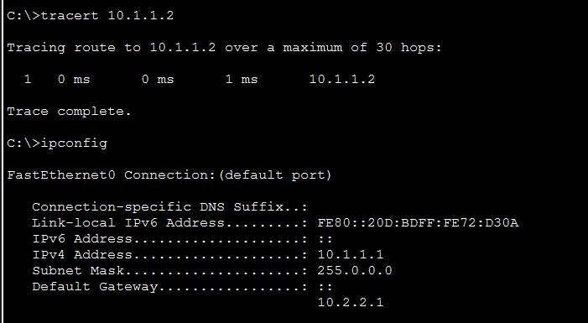
Ping from one machine to the other. If it fails, use ifconfig to ensure the IP addresses are configured correctly.
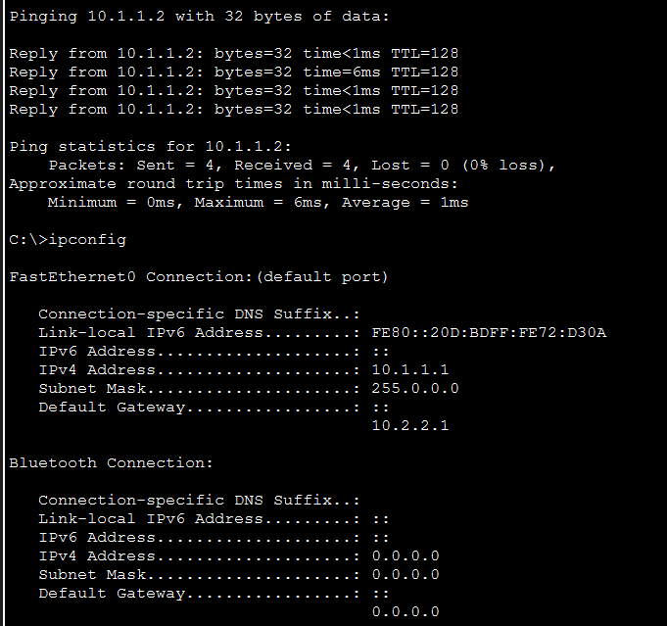
Use traceroute to identify where the packets are being dropped if the ping fails.
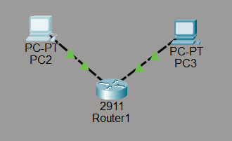
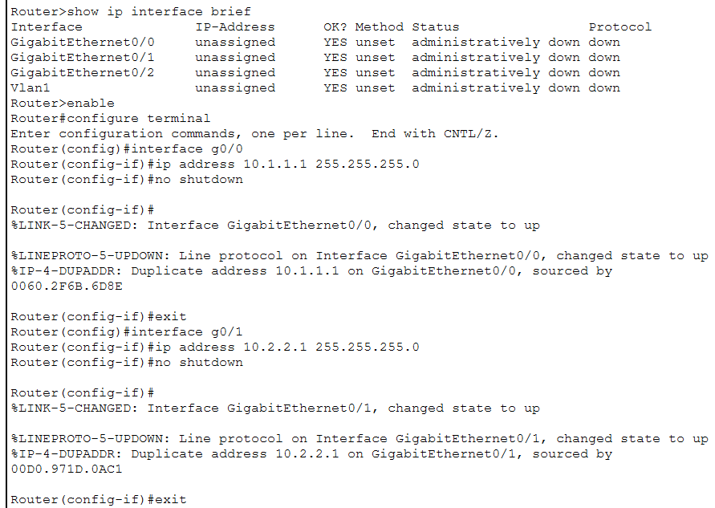
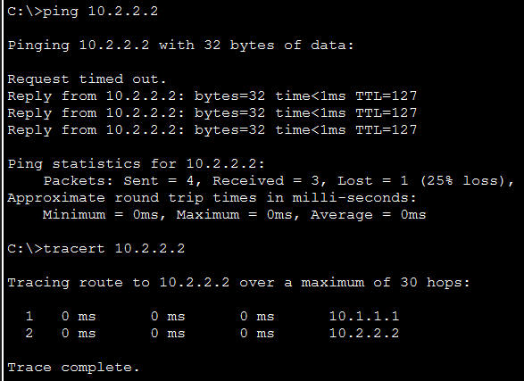

Research the Linux kernel's handling of Ethernet devices and network interfaces. Write a short report on how the Linux kernel supports Ethernet communication (referencing kernel.org documentation).
The Linux kernel is responsible for managing hardware and providing networking capabilities, including support for Ethernet communication. In Linux systems, Ethernet devices such as network interface cards (NICs) are handled through the kernel’s networking subsystem. When a Linux system starts, the kernel detects the available hardware devices and loads the appropriate device drivers for the Ethernet adapter. These drivers act as a bridge between the hardware and the operating system, allowing the kernel to control the network card and handle data transmission. According to documentation from kernel.org, the Linux kernel includes a flexible networking architecture that supports different network devices and protocols. Once the Ethernet driver is loaded, the kernel creates a network interface such as eth0, eth1, or modern predictable names like enp0s3. These interfaces represent the Ethernet device within the operating system and allow the system and user applications to communicate with the network hardware. Through these interfaces, the kernel manages operations such as assigning IP addresses, configuring network parameters, and sending or receiving data packets. The Linux networking stack processes data in layers, beginning with the Ethernet layer at the data link level and continuing through higher-level protocols such as IP, TCP, and UDP. When a user sends data over the network, the kernel packages the data into Ethernet frames and passes them to the network interface driver, which then transmits them through the Ethernet hardware. Similarly, when data is received from the network, the Ethernet driver passes the frames to the kernel, where they are processed by the networking stack and delivered to the appropriate application. The Linux kernel also provides tools and system utilities that allow administrators to manage and monitor Ethernet interfaces, including commands to configure addresses, view network statistics, and troubleshoot connectivity problems. This modular and driver-based design enables Linux to support a wide variety of Ethernet hardware and network configurations efficiently. Overall, the Linux kernel’s networking subsystem, device drivers, and interface management together provide reliable and flexible support for Ethernet communication in Linux-based systems.
Describe how you would configure a basic LAN interface using the ip command in Linux (kernel.org).
To configure a basic LAN interface in Linux, the ip command is commonly used. The Linux kernel manages network devices such as Ethernet cards and allows users to configure them through networking tools. According to documentation from kernel.org, the ip command is part of the iproute2 package and is used to view and manage network interfaces, IP addresses, and routing information. The first step is to identify the available network interface connected to the LAN. This can be done using the command ip link show, which displays the list of interfaces such as eth0 or enp0s3. These names represent the Ethernet network devices on the system. After identifying the interface, the next step is to enable it using the command sudo ip link set dev eth0 up. This activates the interface so that it can send and receive data on the network. Once the interface is active, an IP address must be assigned so that the system can communicate with other devices on the LAN. This is done using the command sudo ip addr add 192.168.1.10/24 dev eth0. Here, 192.168.1.10 is the IP address of the system and /24 represents the subnet mask (255.255.255.0), which indicates the network range. After assigning the IP address, a default gateway can be configured if the system needs to communicate with other networks outside the LAN. This is done using the command sudo ip route add default via 192.168.1.1, where 192.168.1.1 is the router’s IP address. Finally, the configuration can be verified using commands such as ip addr show or ip route show to check whether the interface is active and the IP address is assigned correctly. In this way, the ip command allows beginners to easily configure a basic LAN interface in Linux and enables the system to communicate with other devices on the network.
Use Linux to view the MAC address table of a switch (if using a Linux-based network switch).


Use the bridge or ip link commands to inspect the MAC table and demonstrate a basic


